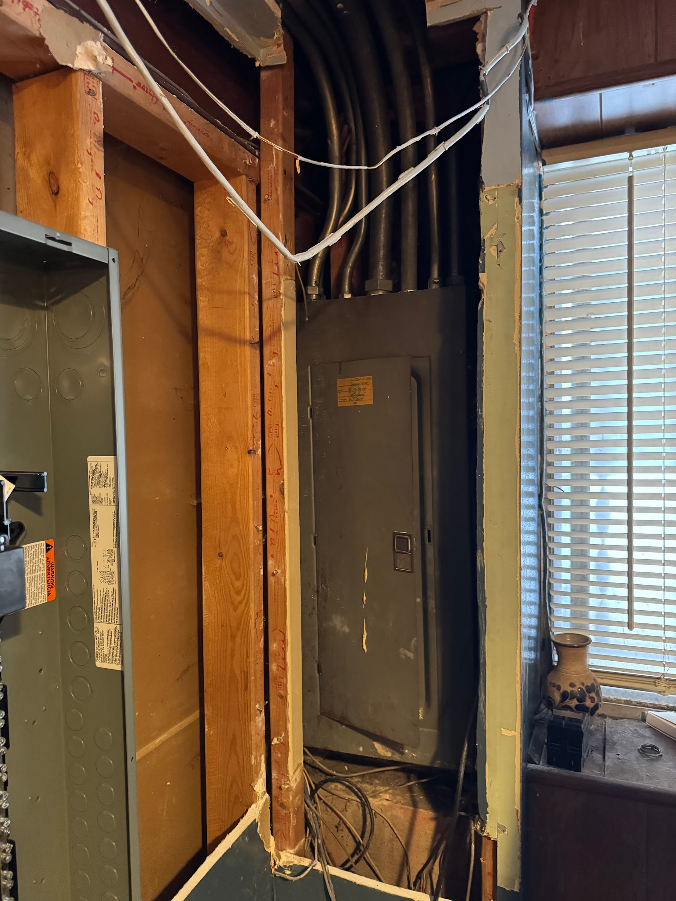

This location is not a good location for a electric panel.There is obstruction in the way of installation. So we have to move new panel on the same east wall Elevation. This install is on the same wall but on the other side of the window.

We currently have have to open up the wall below the window to install additional raceway. removal of panel and drywall below the current window will be require to install an additional 8hr of electrical work required.
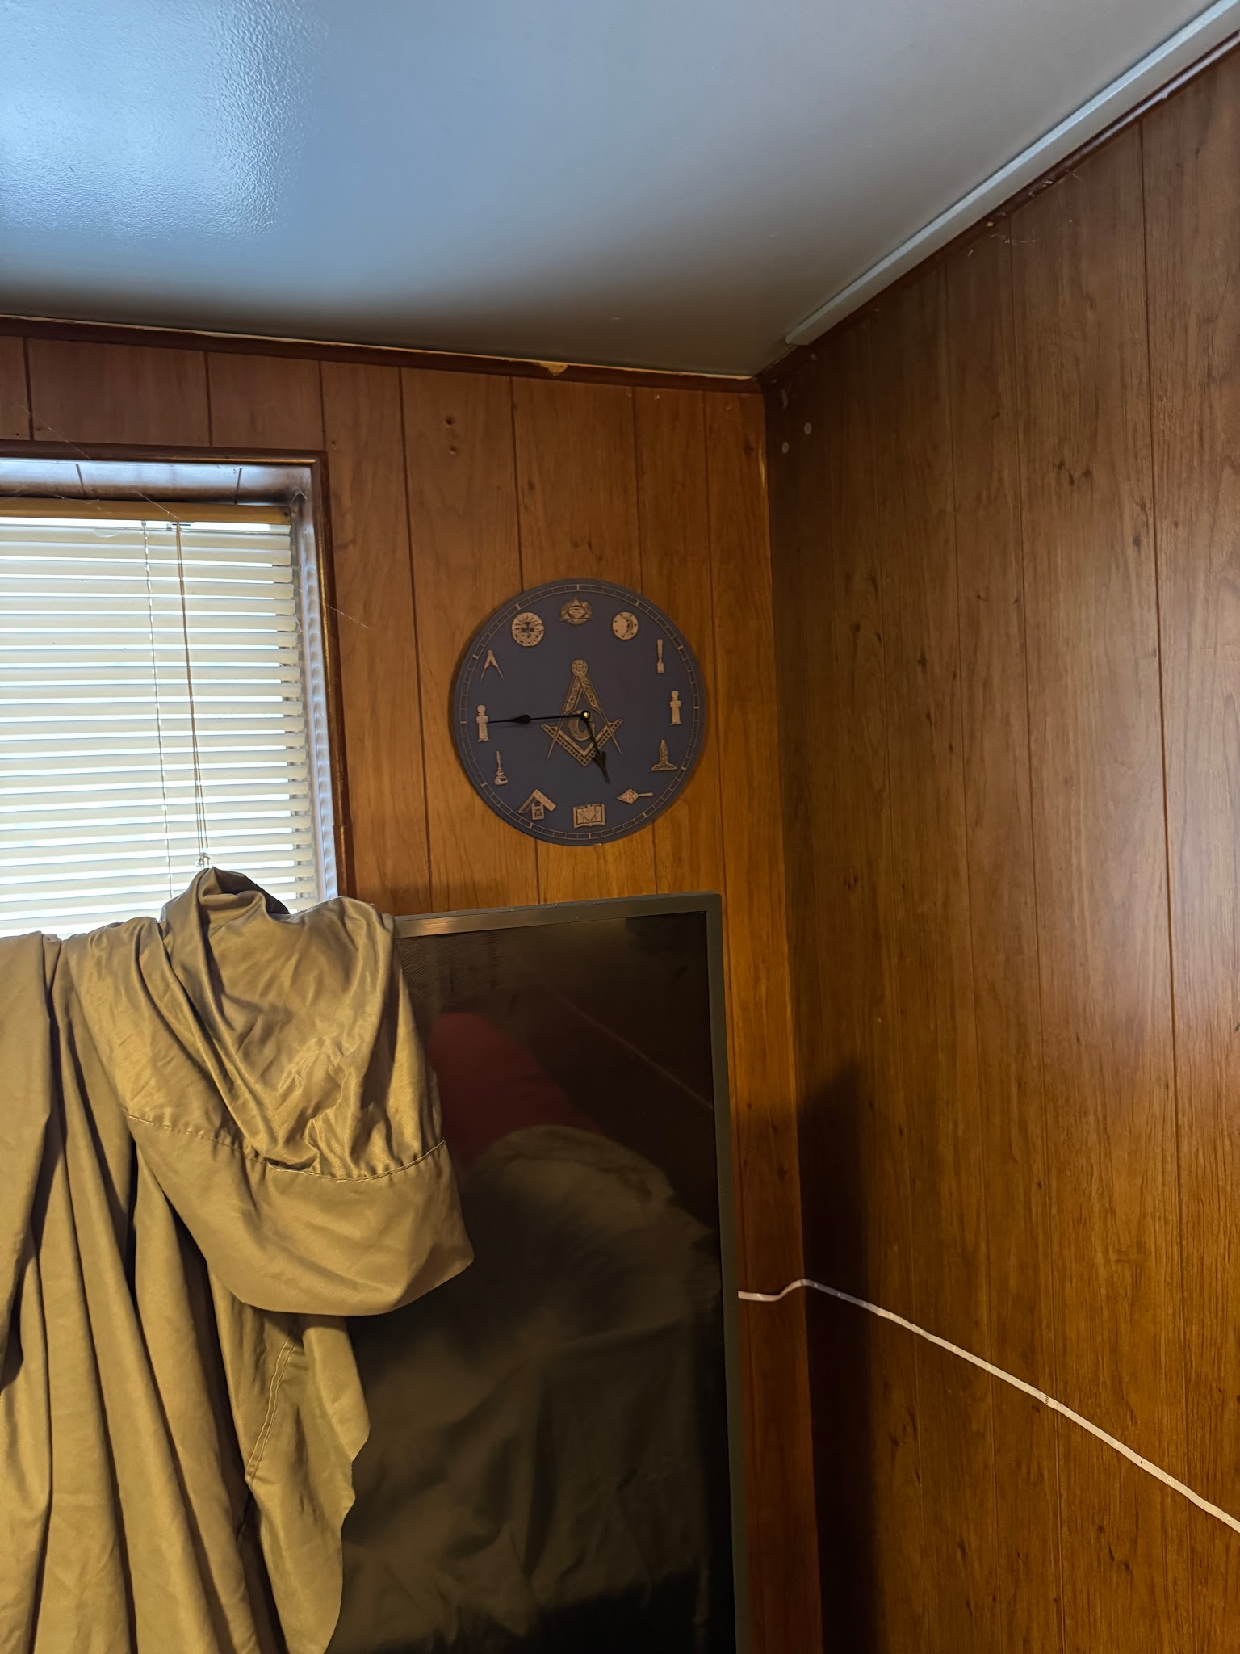

New panel location for the home

